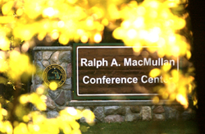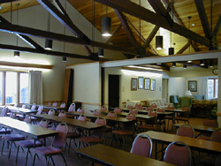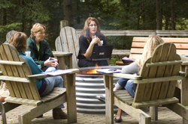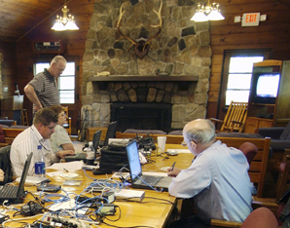

Name_________________

Address________________

City___________________

State___ Zip____________

Phone_________________

Email__________________

Employer_______________

_____Full Conference Registration $220.00

_____One-day Conference w/Lodging $160.00

_____One-day Conference no lodging $120.00 FR or $80.00 SA

_____Add $98.00 for single occupancy

_____Add’l for a guest-call for pricing

_____Total

Make Check payable to

Platinum Educational Group

Or call for

Visa, Mastercard, or AMEX payments call 616-862-1837

www.platinumed.com

* Full Conference Registration includes: Lodging* (based on double occupancy, 2 lunches, 1-dinner, 1-breakfast, snacks, and 10 IC CE credits.
* Friday’s one-day session includes lunch, dinner, and 6 CE credits (4 IT and 2 Ed Admin).
* Saturday’s one-day session includes breakfast, lunch, and 4 credits (4 M&E).

*Single occupancy is an additional fee.

Conference registration is limited! Register now!

**Schedule**

Friday, August 18, 2017

11:30 Registration

12:00 Lunch

1:00 IT Developing and Running a Scenario

5:00 Informal Networking

5:30 Dinner

6:30 Ed Admin Coordination Issues

8:30 Adjourn to the Beach and Fire Pit

Saturday, August 19, 2017

7:15 Breakfast

8:00 M & E Understanding and Using the Stats

12:00 Lunch

**Mail Registration to:**

**Platinum Educational**

**Group**

**4370 Chicago Dr, Ste B205**

**Grandville, MI 49418**

**Call 616-890-1096**

**No Refunds after 8/4/17**

Registration Deadline is Aug. 4, 2017 No refunds after the Deadline

Register online--www.platinumed.com

# Conference Registration is Limited

# Conference Registration is limited

Platinum Educational Group

Presenters:

Doug Smith, MAT, EMT-P, IC

Platinum Educational Group

Ralph Elam, EMT-P, IC

Superior Medical Education-A Division of Dorsey Schools

John Spencer, EMT-P, IC

Platinum Educational Group

Questions-Call Doug

616-890-1096

# Why Attend

Sessions offer high-quality CE in a casual and comfortable environment.

For those who remember the Higgins experience and for those who have never experienced Higgins and would like to.

4370 Chicago Dr, Ste B205  
 Grandville, MI 49418

Phone: 616-890-1096

www.platinumed.com

7th Annual Higgins Lake Revisited

Instructor Coordinator Continuing Education Workshop

August 18 & 19, 2017

Ralph A MacMullen DNR Conference Center

104 Conservation Drive, Roscommon, MI 48653, 1.5 miles east of US 27 and five miles west of I-75.

Presents